

GROUP MEMBERS: Student1364052 NIMRAH KHALID, Student1367274 SHEHZONIA FATIMA, Student1365943 AREEBA RIAZ, Student1358755 RANA FAHAD JAVED & Student1365677 MUHAMMAD SUBHAN ALI KHAN

Contents

**CERTIFICATE OF COMPLETION** 3

**ACKNOWLEDGEMENT** 4

**PROPOSED SYSYTEM:** 5

**Hardware and Software Requirements** 8

**Hardware** 8

**Software** 8

**Operating System** 8

**Website Features** 9

**USER’S GUIDE** 10

**CONTACT US** 10

11

**PATIENT’S REGISTERATION FORM** 12

**LOGIN** 13

**HOSPITAL DETAILS AND DASHBOARD** 14

**PATIENT DETAILS AND DASHBOARD** 14

14

**USER’S GUIDE** 15

**DATABASE STRUCTURES** 16

# **CERTIFICATE OF COMPLETION**

This is to clarify that **Nimrah Khalid**,**Shehzonia Fatima,Areeba Riaz,Rana Fahad Javed and Muhammad Subhan Ali Khan** have successfully completed their ACCP Semester 2 E-Project.

Submitted to Aptech Computer Education on

December 24th,2022

# **ACKNOWLEDGEMENT**

First of all we would like to thank Almighty Allah for giving us strength and ability to complete this project.

And then, we would like to express our special thanks of gratitude to our teacher **Sir Faizan Sabir** who guided us on the project *CMS Covid Management System*, which also helped us in doing a lot of new learning and we came to know about so many new things we are really thankful to him.

We are highly thankful to **Sir Faizan Sabir** for his guidance and constant supervision as well as for providing necessary information regarding the project & also for his support in completing the project.

We earnestly hope that this project will provide all the necessary information required by the user to fulfill his/her inspiration.

# **PROPOSED SYSYTEM:**

App will provide Online Registration System (ORS) is a framework to link various hospitals across the country for mobile number based online registration and appointment system. Portal facilitates online appointments for vaccination. Detail reports showing information about test and vaccination patients taking appointment through this portal can be seen. Hospitals can come on board this platform and provide their appointment slots for online booking by patients. The system facilitates Hospitals to easily manage their registration and appointment process and monitor the flow of

Patients.

**Front end Section**

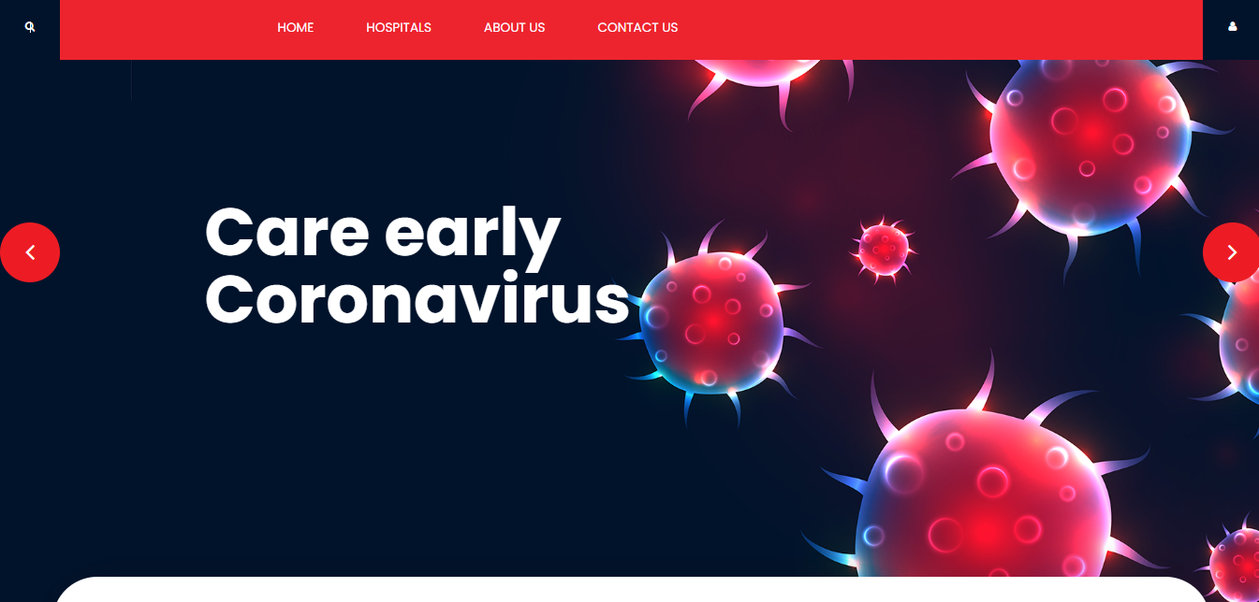

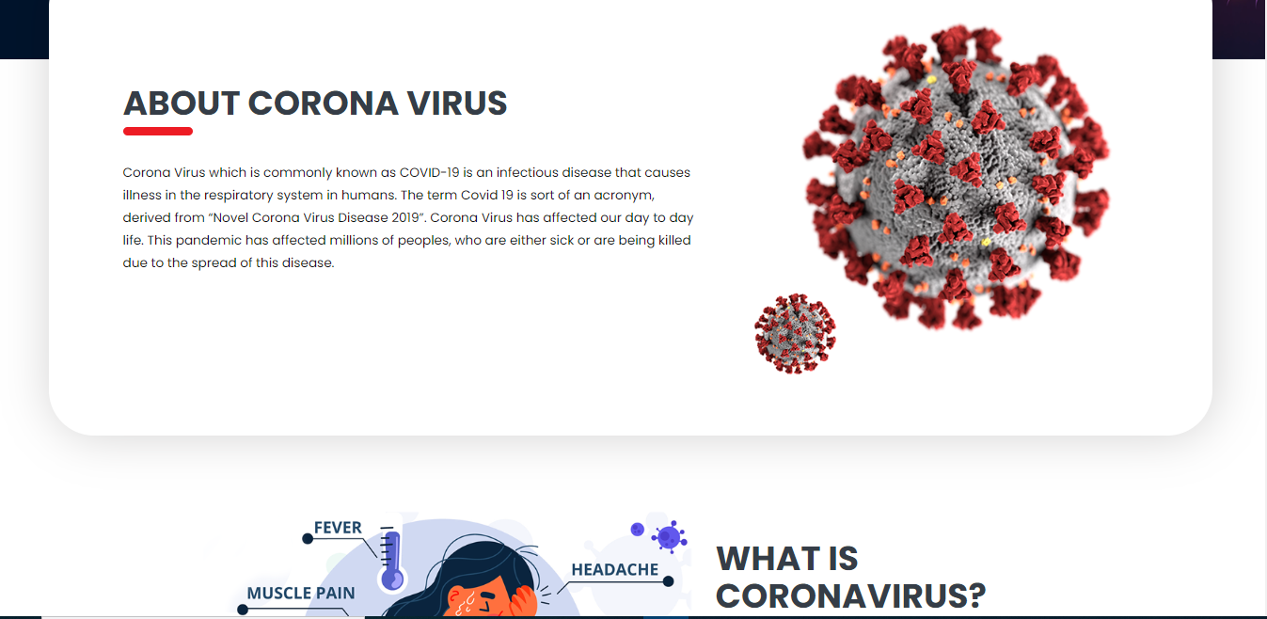

666

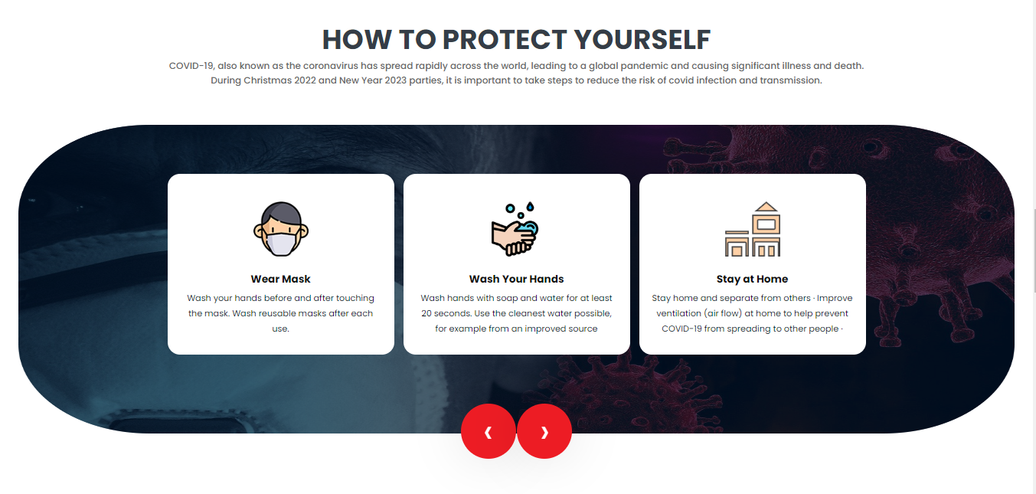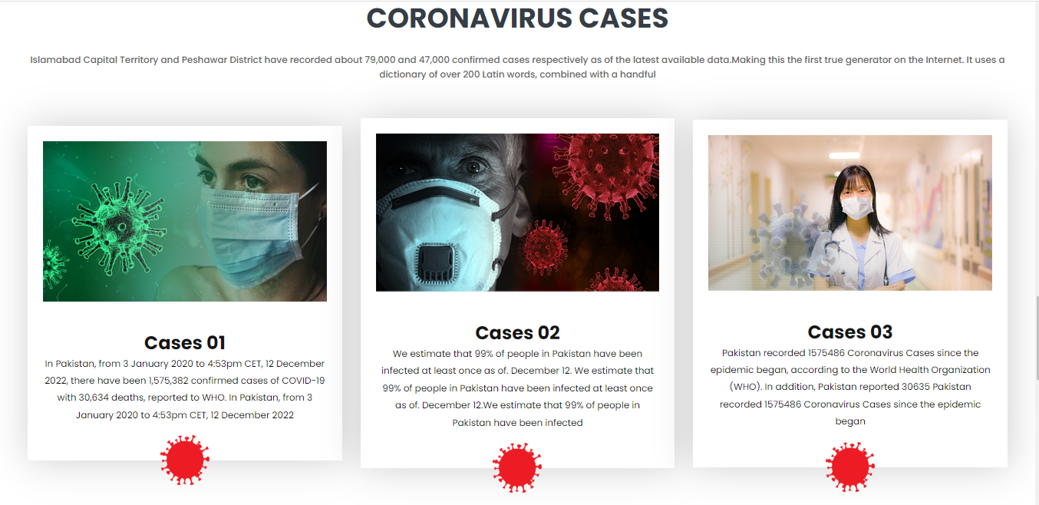­­­­­­

# **Hardware and Software Requirements**

## 

## **Hardware**

* A minimum computer system that will help you access all the tools in the courses is a Pentium 166 or better.
* 128 Megabytes of RAM or better **Software**

**Software**

* PHP
* MySQL
* PERL
* Apache

**Operating System**

* LINUX / Windows 2000 Server (or higher if possible)

# **Website Features**

The website CMS (Covid Management System) provides facilities to patients to book their appointments online by visiting the website. There are different hospitals registered on CMS. Hospitals And Patients both have to register first on the website.

# **USER’S GUIDE**

**HOMEPAGE(landing page)**

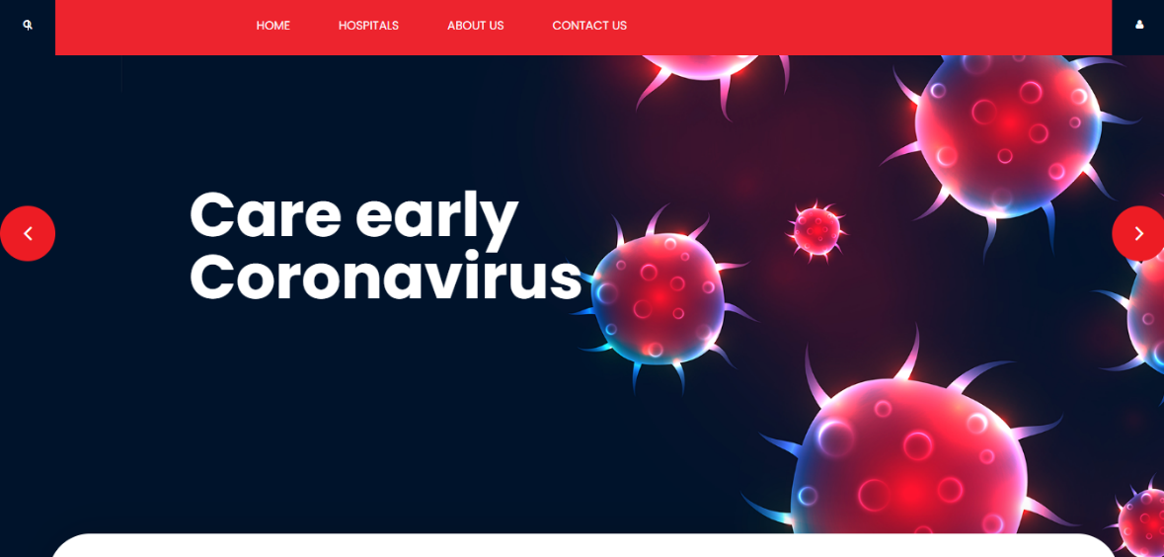

## **CONTACT US**

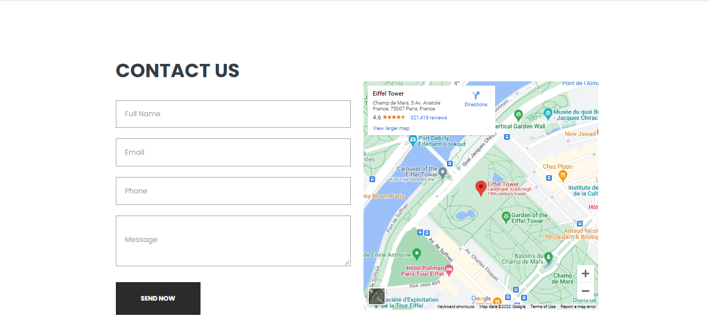

**Sign up Page**

## 

## **PATIENT’S REGISTERATION FORM**

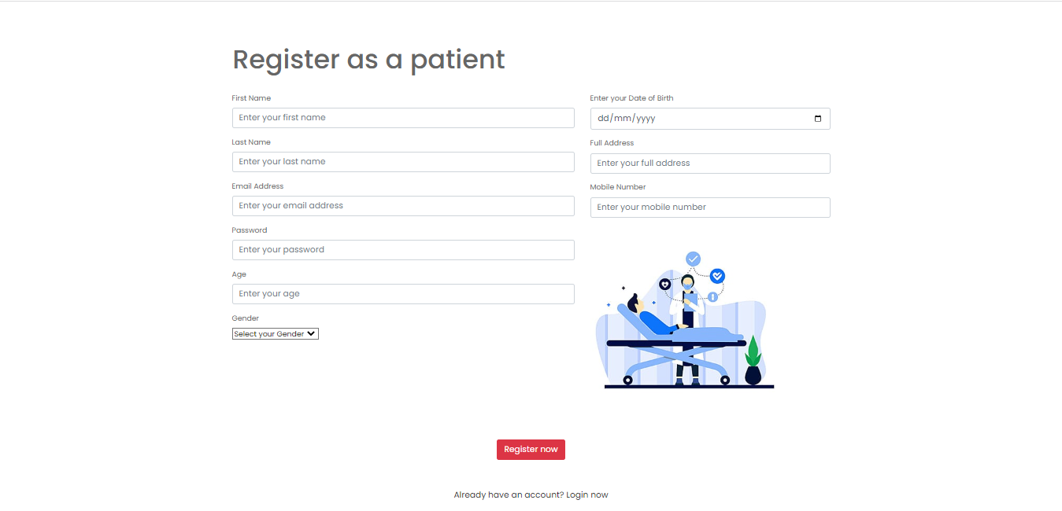

**HOSPITAL REGISTERATION FORM**

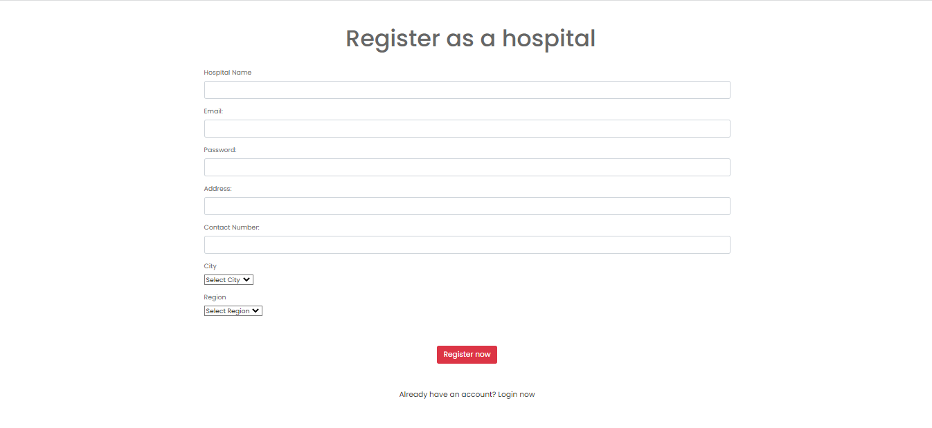

**Back end Section**

## **LOGIN**

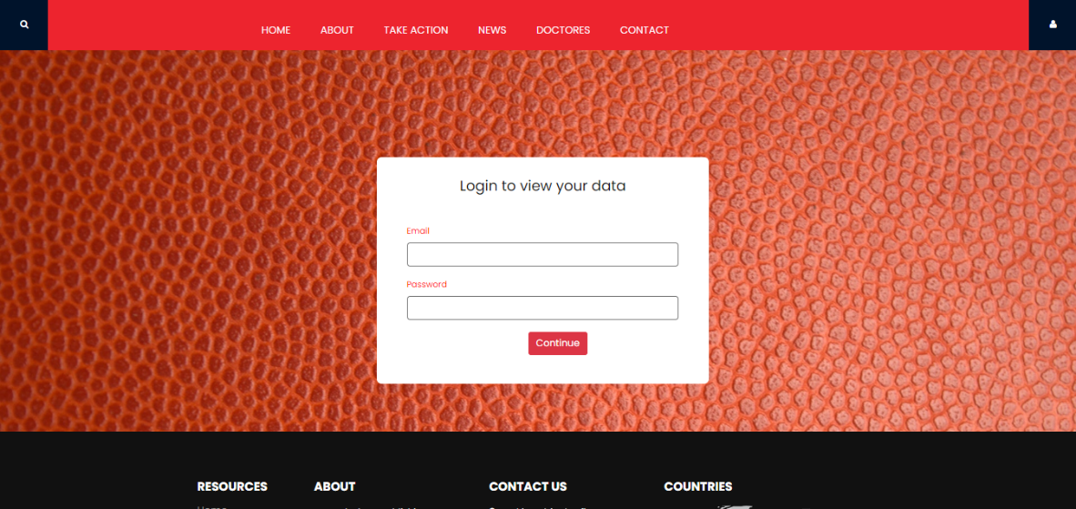

## **HOSPITAL DETAILS AND DASHBOARD**

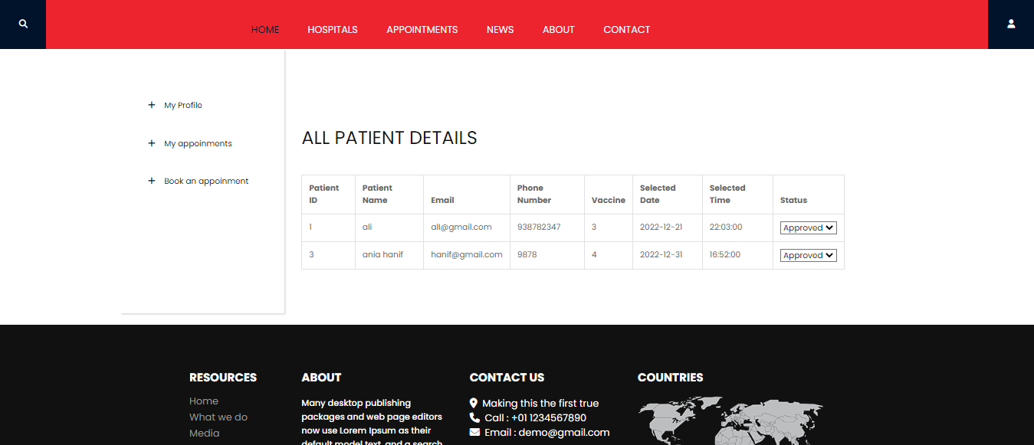

## **PATIENT DETAILS AND DASHBOARD**

# 

# **USER’S GUIDE**

You need Email & Password to login Admin Panel.

1. Username: [CMSadmin@gmail.com](mailto:CMSadmin@gmail.com)

2. Password: xeschms1010

You need Email & Password to login Patient Dashboard.

1. Username: ali@gmail.com

Password: 1234

2. Username: shafaq@gmail.com

Password: 151515

3. Username: [nimrah1149@gmail.com](mailto:nimrah1149@gmail.com)

Password: nimrah1234

You need Email & Password to login Hospital Dashboard.

1. Username: al khidmat@gmail.com

Password: 1234

2. Username: [shifah@gmail.com](mailto:shifah@gmail.com)

Password: sh1234

**DATABASE STRUCTURES**

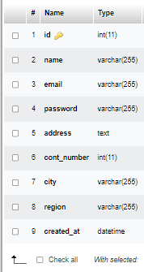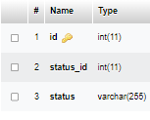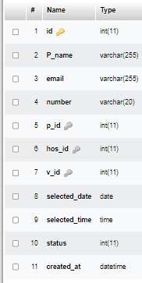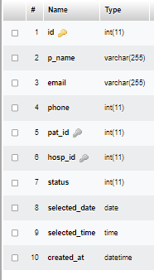Appointments Bookings Booking Status Hospital

Patients Pat-list Vaccine

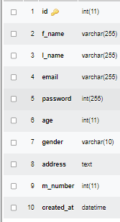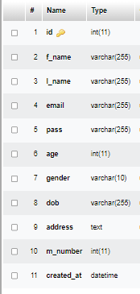

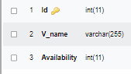

**DATABASE**

We use seven tables for this project.

1. Bookings
2. Hospital
3. Patients
4. Vaccine
5. Admin
6. Message